**THE FULLCAM CARBON ACCOUNTING MODEL**

FullCAM has components that deal with the biological and management processes which affect carbon pools and the transfers between pools in forest, agricultural, transitional (afforestation, reforestation, deforestation) and mixed (eg. agroforestry) systems. It is an integrated compendium model that provides the linkage between the various sub - models. These models have been independently developed for the various purposes of predicting and accounting for:

• soil carbon change in agriculture and forest activities

• the determination of rates of decomposition of litter

• the prediction of growth in trees.

With FullCAM, it is possible to represent the transitional afforestation, reforestation and deforestation (change at one site) or mix of agricultural and forest systems (discrete activities at separate sites).

FullCAM provides the capacity for Australian scale modelling at a fine spatial resolution (grids) of 1 hectare. This initially envisaged approach relied on the use of averaged model inputs (conditions) over both space and time.

The fine spatial resolution, activity-driven and time-based modelling provides a capacity to report at both project and continental scales, in response to specific activities, and with sensitivity to the timing of an activity.

Registered offsets projects under the Carbon Farming Initiative must follow this guidance when using the Carbon Credits (Carbon Farming Initiative) (Reforestation by Environmental or Mallee Plantings—FullCAM) Methodology Determination 2014 (the Determination).

When estimating abatement using FullCAM the following requirements apply:

* The latest public release version of FullCAM (available on the Department’s website) must be used for each reporting period and version 3.55 of FullCAM or higher must be used.
* For projects under the Determination, separate plot files must be created for each carbon estimation area (CEA).
* For each CEA, separate plot files must be created for:
* estimating monthly carbon stocks under the project activity for the current reporting period
* determining if a disturbance event must be reported prior to the next reporting period.
* Where a new version of FullCAM has been released between reporting periods, new plot files for each CEA may need to be created.
* The increase in the modelled project carbon stocks between reporting periods (or project commencement), minus included emissions within the reporting period, forms the basis of abatement calculations and subsequent issuing of Australian carbon credit units (ACCUs).
* The maximum age of tree growth for simulations using a specific calibration is 15 years. Only simulations using the generic mixed species environmental calibration can run simulations up to 100 years.

Furthermore, the model provides specific GIS data for the spatial domains for the specific calibrations.

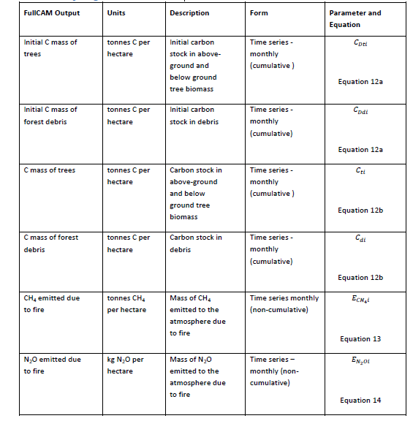

**Table 1. Outputs generated in FullCAM (Author:** **Guidance for using the Full Carbon Accounting Model (FullCAM) in Carbon Farming Initiative )**

**References:**

Richards, G. 2001. THE FULLCAM CARBON ACCOUNTING MODEL: DEVELOPMENT, CALIBRATION AND IMPLEMENTATION FOR THE NATIONAL CARBON ACCOUNTING SYSTEM. National Carbon Accounting System. Technical Report No. 28. https://www.semanticscholar.org/paper/THE-FULLCAM-CARBON-ACCOUNTING-MODEL-%3A-DEVELOPMENT-%2C-Richards/7aa6fac6b3ae6a60720292758ad76db490f62795

Guidance for using the Full Carbon Accounting Model (FullCAM) in Carbon Farming Initiative (CFI) Methodologies Carbon Credits (Carbon Farming Initiative) (Reforestation by Environmental or Mallee Plantings—FullCAM) Methodology Determination 2014. Version 1.0 . <https://www.environment.gov.au/system/files/pages/c9547241-6714-485f-8f1e-de75db952e52/files/fullcam-guidance-ep-mallee.pdf>